

SRI LANKA INSTITUTE OF INFORMATION TECHNOLOGY

[**Enterprise Standards and Best Practices for IT Infrastructure**](http://courseweb.sliit.lk/course/view.php?id=137)

**4th Year 2nd Semester 2014**

Name: L.A.C.Dissanayake.

SLIIT ID:IT13147006

Group Number:

Practical Session: WD

Practical Number : Lab 02

Date of Submission: 30/07/2016

Date of Evaluation : _____________________

Evaluators Signature : _____________________

Introduction

Amazon Web Services provides an AWS Free Tier option for evaluation purposes. The AWS Free Tier provides access to many products and services, including Amazon EC2, at no cost, within certain limitations. After completing the steps to [create a Free Account](https://portal.aws.amazon.com/gp/aws/developer/registration/index.html?nc1=f_ct), you can quickly create a "Free Tier Eligible" instance of Linux with a public IP address that you can use to increase your knowledge of Linux concepts.

**1.Create a Linux** **instance**

* **Launch an instance**

Open the Amazon EC2 console at <https://console.aws.amazon.com/ec2/>

From the console dashboard, choose **Launch Instance**

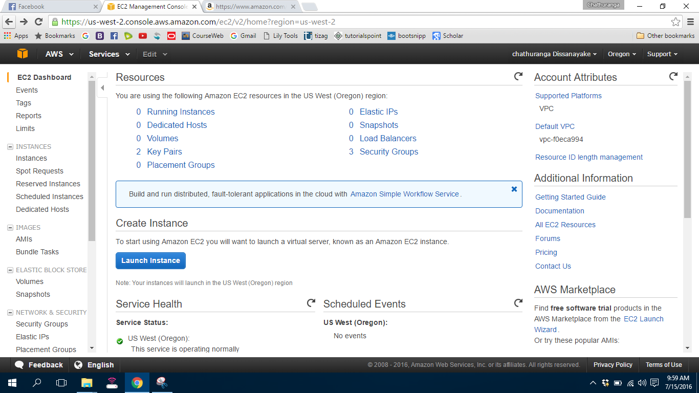

* The **Choose an Amazon Machine Image (AMI)** page displays a list of basic configurations. Select the HVM edition of the Amazon Linux AMI.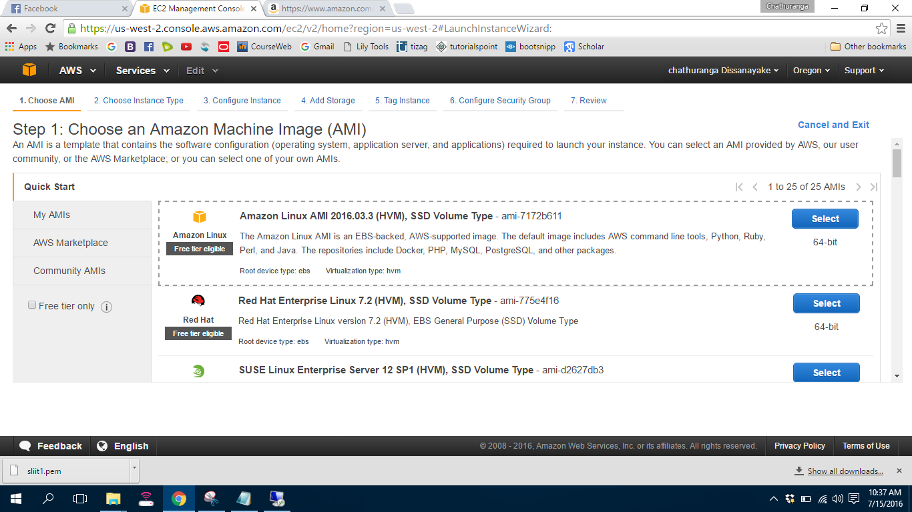
* On the **Choose an Instance Type** page, you can select the hardware configuration of your instance. Select the t2.micro type

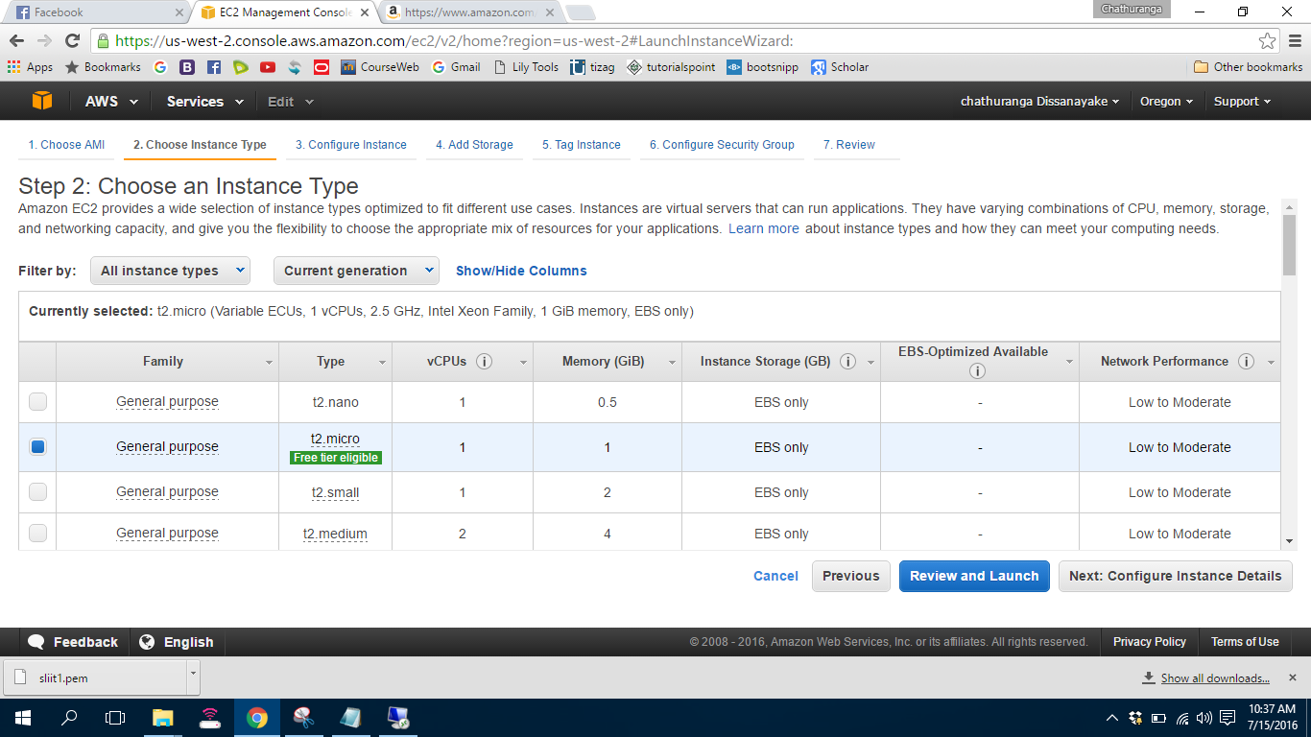

* Choose **Review and Launch** to let the wizard complete the other configuration settings for you

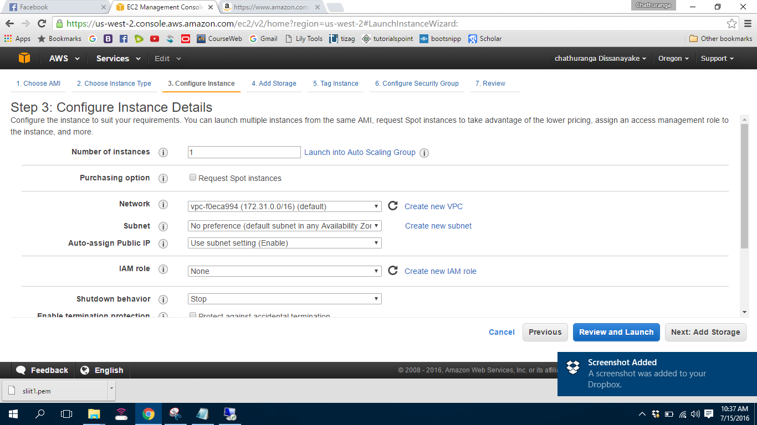

* On the **Review Instance Launch** page, choose **Launch**.

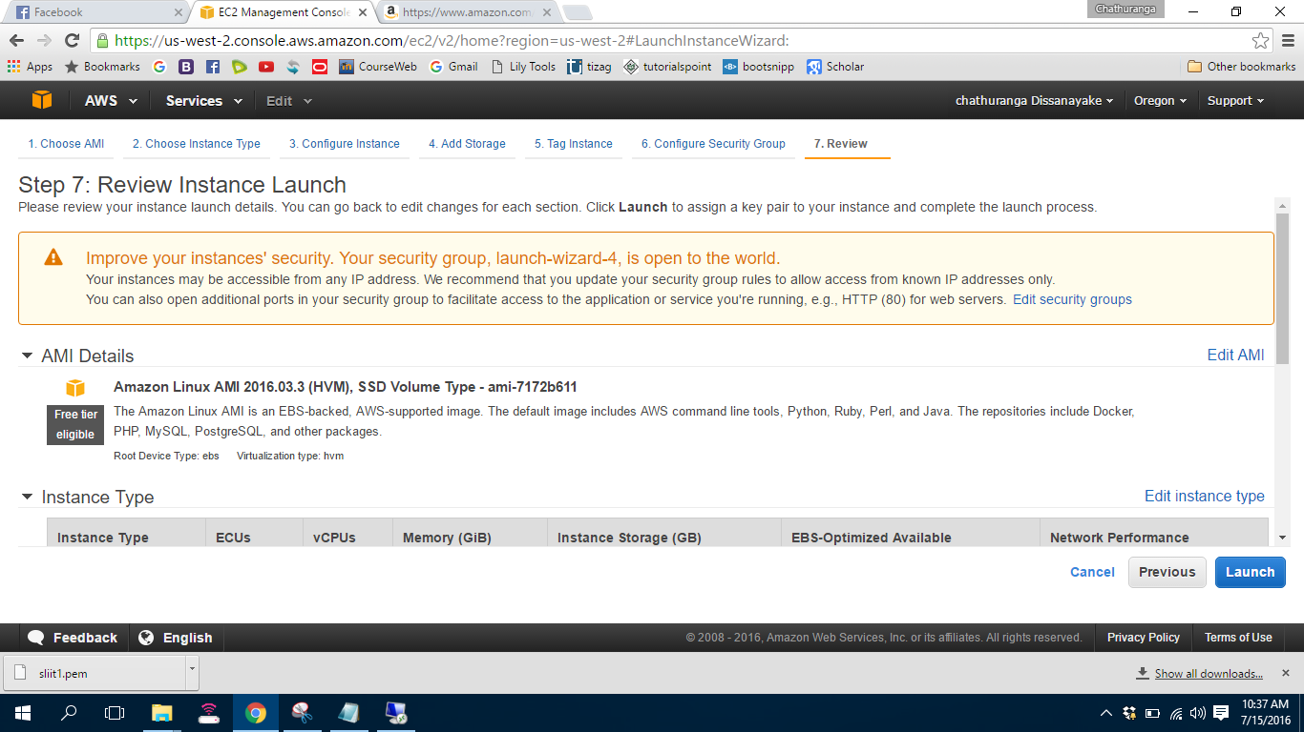

* When prompted for a key pair, select **Choose an existing key pair.** Then  Select **Create a new key pair**, enter a name for the key pair, and then choose **Download Key Pair**.

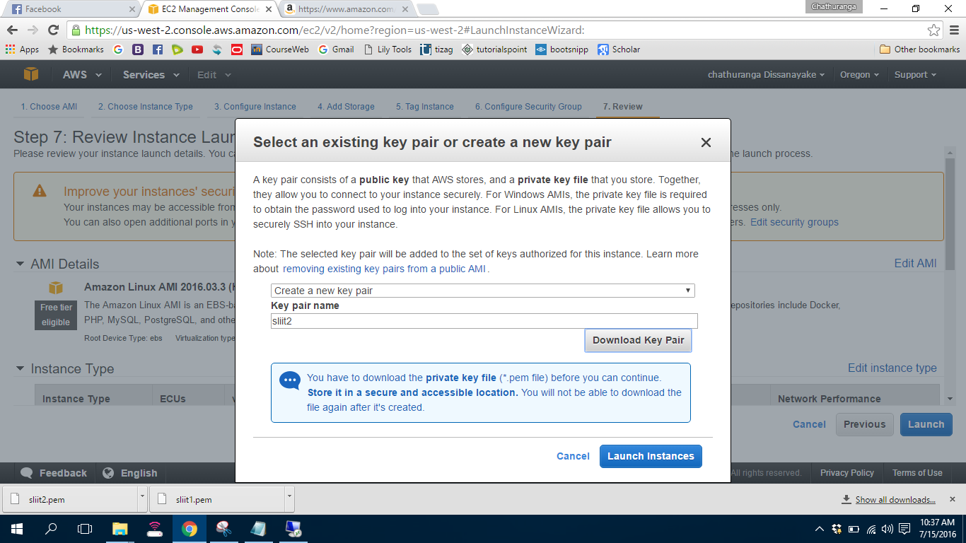

* Choose **View Instances** to close the confirmation page and return to the console.

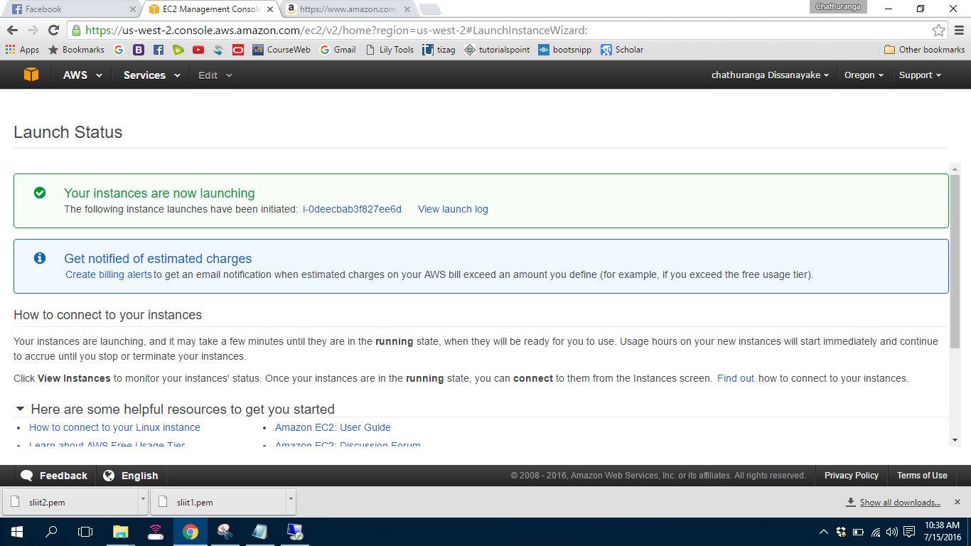

* On the **Instances** screen, you can view the status of the launch. It takes a short time for an instance to launch. When you launch an instance, its initial state is pending. After the instance starts, its state changes to running and it receives a public DNS name. (If the **Public DNS** column is hidden, choose the Show/Hide icon in the top right corner of the page and then select **Public DNS**.)

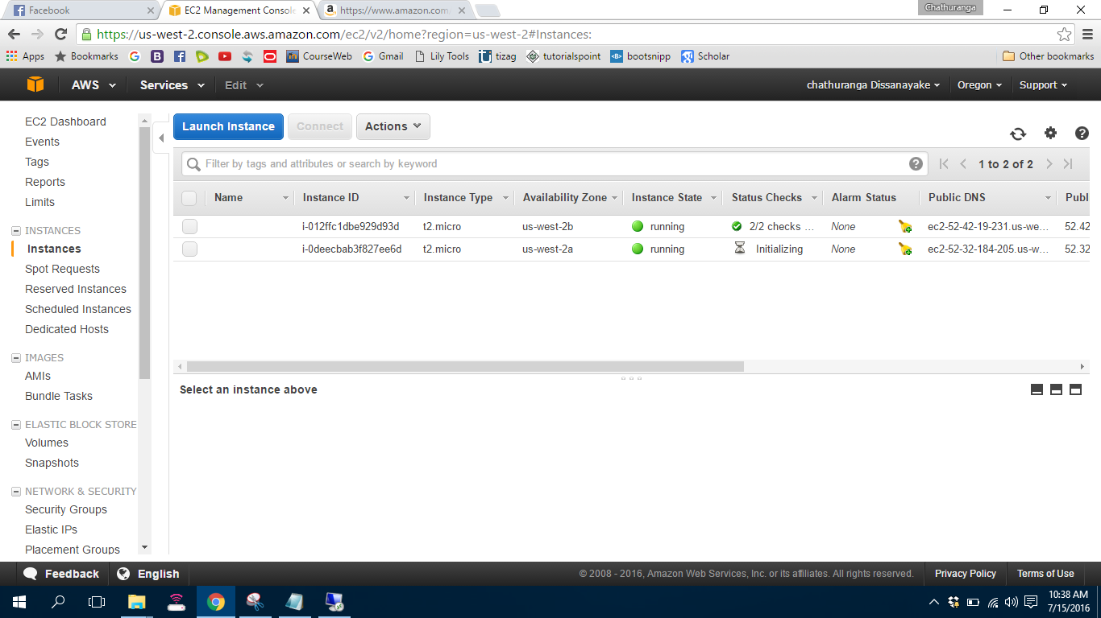

* [Connecting to Your Linux Instance from Windows Using PuTTY](http://docs.aws.amazon.com/AWSEC2/latest/UserGuide/putty.html) or [connecting to Your Linux Instance Using SSH](http://docs.aws.amazon.com/AWSEC2/latest/UserGuide/AccessingInstancesLinux.html).

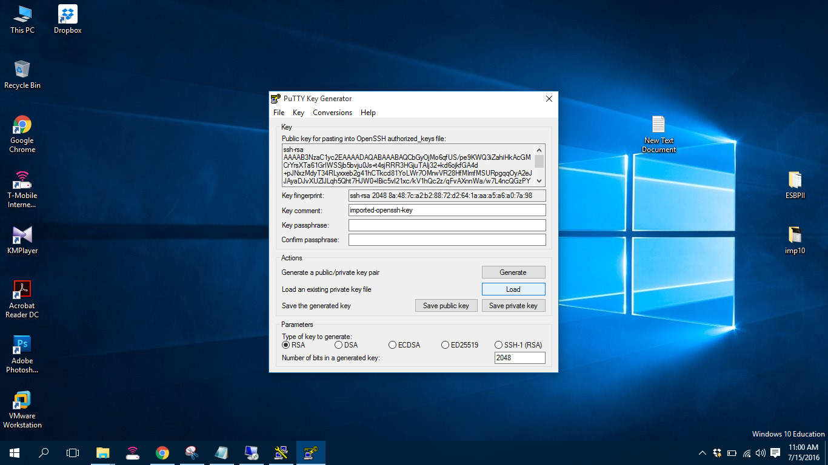

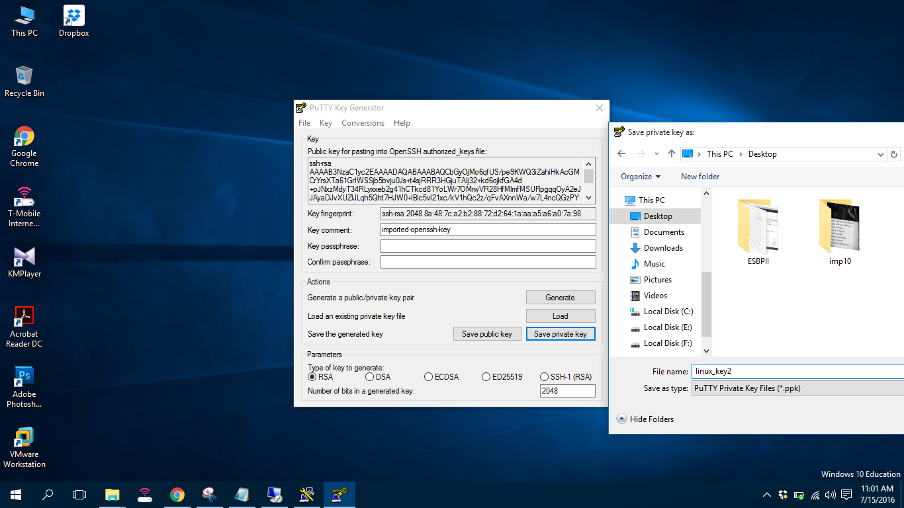

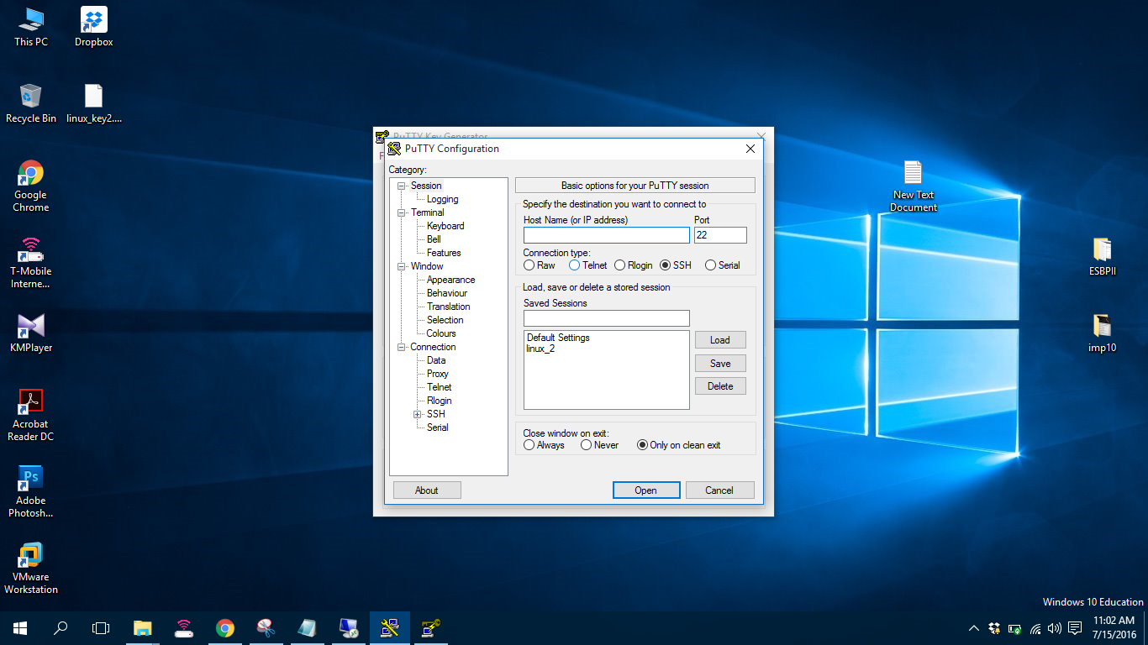

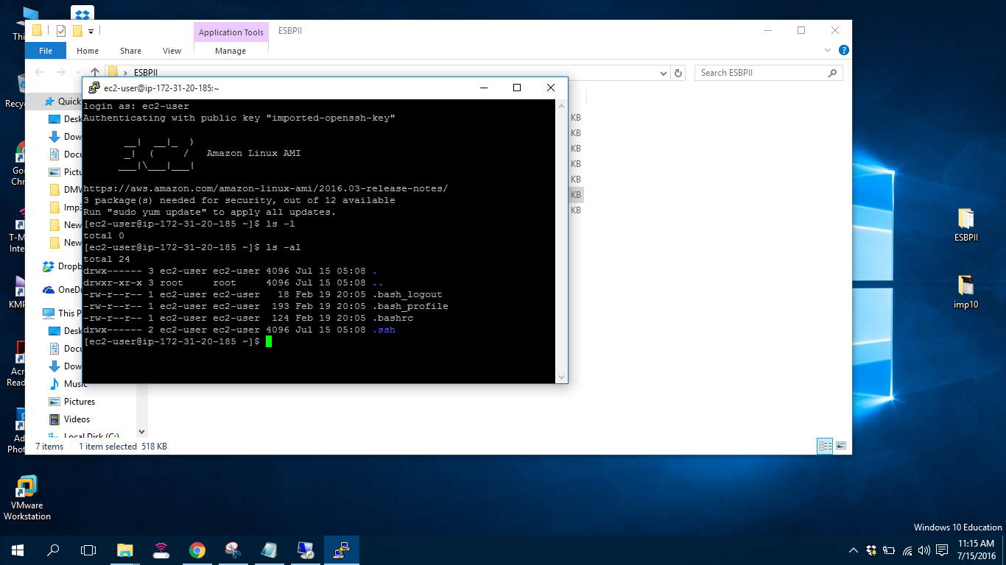

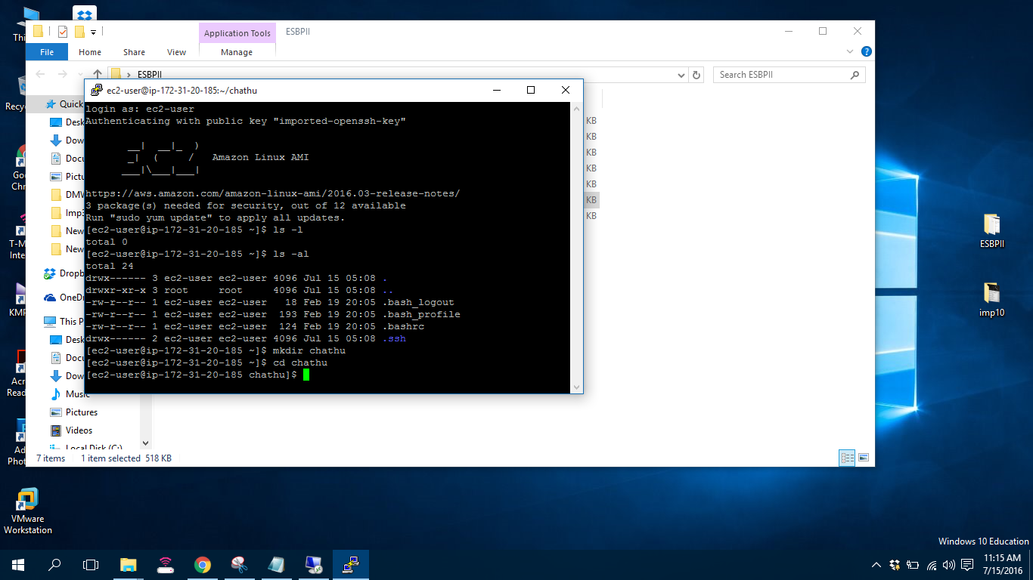

Referance

1. <https://console.aws.amazon.com/ec2/>
2. <http://docs.aws.amazon.com/AWSEC2/latest/UserGuide/EC2_GetStarted.html>
3. <http://www.chiark.greenend.org.uk/~sgtatham/putty/download.html>